CENWP-ODJ 5/3/2023

MEMORANDUM FOR THE RECORD

SUBJECT: 23JDA14 Chinook Mort

On Tuesday May 2nd, 2023, at approximately 1400, a Chinook mort was discovered in the emergency overflow section just upstream from the Primary Dewatering Structure (PDS). It was in an area that was inaccessible, so further examination was not possible. It appeared to have been there for a few days to a week. Project Fish will determine if deploying netting over the area is possible to prevent fish from jumping in the future.

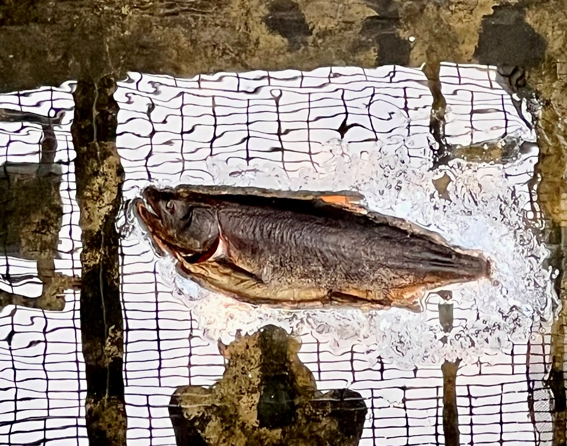

- Species – Chinook
- Origin – Unknown
- Length – Unknown
- Marks and tags – Unknown
- Marks and Injuries found on carcass – Unknown
- Cause and Time of Death – Unknown
- Future and Preventative Measures – Deploy netting in the area to prevent fish from jumping.
Sincerely,
JDA Project Fisheries

